**Table 1. Landscape attributes and diversity and aggregation estimates for each meadow**. Fetch was estimated by XYZ. Beta … The total number of epifaunal species observed in each meadow (gamma.site) and the Chao estimate for site-level epifaunal richness are given. Chao estimates are based on extrapolated estimates to 2x minimum? Abundance following Chao et al (2014). Aggregation indices for all epifaunal species in the meadow (Im) with standard errors are given; meadows with significant aggregation across species are indicated in bold (95% CIs do not include 0.5) (ref). The proportion of species present in the meadow with significant I values based on Χ2 tests is also given.

|  |  |  |  |  |  |  |  |
| --- | --- | --- | --- | --- | --- | --- | --- |
| Site | Area (ha) | Fetch | Bsite | gammasite | Im | Rsite based on chao et al | Proportion of species with significant I |
| DC | 2.30 |  | 13.31 | 17 | 0.47  (0.34 – 0.59) | 18.2  (10.0, 26.4) | 91 |
| WI | 0.26 |  | 14.47 | 18 | 0.41  (0.25 – 0.57) | 19.8  (11.5, 27.8) | 83 |
| BE |  |  | 13.94 | 17 | 0.50  (0.34 – 0.65) | 22.2  (4.78, 39.7) | 90 |
| EI |  |  | 9.38 | 13 | 0.44  (0.28 – 0.60) | 12.3  (7.6, 16.9) | 82 |
| RP | 0.72 |  | 15.06 | 22 | **0.57**  **(0.51 – 0.64)** | 29.4  (19.6, 39.2) | 93 |
| NB | 2.70 |  | 12.69 | 16 | 0.46  (0.28 – 0.64) | 19.0  (10.7, 27.3) | 88 |
| CB | 0.50 |  | 10.13 | 14 | 0.53  (0.37 – 0.69) | 14.0  (9.0, 20.0) | 89 |
| BI |  |  | 12.75 | 17 | 0.38  (0.21 – 0.55) | 17.0  (12.4, 21.6) | 77 |
| CC |  |  | 7.19 | 10 | **0.23**  **(0.03 – 0.40)** | 9.0  (8.0, 10.9) | 67 |

**Table 2: Relative abundance of species in each meadow.** Numbers indicate the rank of abundances relative to other species in that meadow at that time. Species with significant spatial intraspecific aggregation within the meadow, estimated as Morisita’s Index, are indicated in bold. Significance determined by chi-squared tests and P < 0.05. [*I should probably make a printout of the Im results in case we do a bonferroni*] [add a symbol to indicate grazer]

|  |  |  |  |  |  |  |  |  |  |  |  |  |  |  |  |  |  |  |  |  |
| --- | --- | --- | --- | --- | --- | --- | --- | --- | --- | --- | --- | --- | --- | --- | --- | --- | --- | --- | --- | --- |
| **Species** | **T** | **DC** | | | **WI** | | | **BE** | **EI** | **RP** | | | **NB** | | | **CB** | | | **BI** | **CC** |
|  |  | **M** | **J** | **A** | **M** | **J** | **A** | **J** | **J** | **M** | **J** | **A** | **M** | **J** | **A** | **M** | **J** | **A** | **J** | **J** |
| ***Crustacean*** |  |  |  |  |  |  |  |  |  |  |  |  |  |  |  |  |  |  |  |  |
| *Caprella spp.* | 1 | 1 | **1** | 2 | 9 | **5** | 2 | **1** | **4** | 1 | **1** | 2 | 11 | 11 | 6 | 3 | **6** | 4 | 14 | 4 |
| *Aoroides columbiae* | 7 | 2 | **2** | 3 | 5 | 11 | 7 | 10 | **6** | 3 | **8** | 5 |  | 7 | 8 |  | **7** | 13 | **8** |  |
| *Pentidotea resecata* | 8 | 4 | **4** | 5 | 7 | **3** | 5 | **3** | 11 | 6 | **9** | 8 | 1 | **3** | 4 | 2 | **5** | 8 | **6** | 5 |
| *Leptochelia dubia* | 9 |  | 16 | 10 | 10 |  |  | 16 |  | 5 | **5** | 7 | 7 | **5** | 12 | 5 | **4** | 2 | **4** | 7 |
| *Photis brevipes* | 12 | 5 | **3** | 8 | 4 | **7** | 6 | 5 | **7** | 9 | **6** | 9 | 5 | 8 | 3 | 8 | **8** | 5 |  |  |
| *Monocorophium achersicum* | 13 | 6 | **6** | 6 | 14 | 9 | 14 |  |  |  | **18** |  | 9 |  | 9 | 12 | 9 | 6 | 12 | 9 |
| *Amphipod E* | 15 |  | **8** |  | 18 | 15 |  | **2** |  | 10 |  |  |  |  |  | 7 |  |  | **5** | 3 |
| *Pontogeneia rostrata* | 16 | 9 | **5** |  | 2 |  | 8 | 14 | 12 |  | 15 |  | 8 | 15 | 15 | 10 | 13 |  | 10 |  |
| *Harpacticoid copepod* | 17 | 12 | 13 | 16 | 11 | 12 | 18 |  |  |  | **11** | 12 | 3 |  | 5 | 13 |  | 10 |  |  |
| *Eogammarus confervicolus* | 18 | 7 | 12 |  | 12 |  | 16 | **8** | 9 |  |  |  | 13 | 12 |  |  |  |  |  |  |
| *Ampithoe spp.* | 19 | 11 |  | 15 | 13 | 14 | 13 |  |  |  | **16** |  | 14 | 9 | 10 |  |  |  | 15 |  |
| *Balanus spp.* | 21 |  |  | 18 |  |  | 15 |  | 10 |  | **20** | 16 | 16 | 14 | 14 |  |  | 17 |  |  |
| *Cirolana harfordi* | 23 |  | 15 |  | 8 | 13 | 17 | 15 |  |  | **21** |  |  |  |  |  |  |  |  |  |
| *Pugettia richii* | 24 | 13 | 11 | 11 |  |  | 21 |  |  |  |  | 15 |  |  |  |  |  |  |  |  |
| *Pandalidae* | 26 |  |  | 14 |  |  | 20 | 17 |  |  | **17** | 10 |  |  |  |  |  |  |  |  |
| *Pagurus quaylei* | 29 | 14 |  |  | 16 |  | 22 |  |  |  |  |  |  |  |  |  |  |  | 16 |  |
| *Nebalia sp.* | 30 |  |  |  |  |  |  |  |  |  |  |  | 15 |  |  |  |  | 15 |  |  |
|  |  |  |  |  |  |  |  |  |  |  |  |  |  |  |  |  |  |  |  |  |
| ***Gastropod*** |  |  |  |  |  |  |  |  |  |  |  |  |  |  |  |  |  |  |  |  |
| *Phyllaplysia taylori* | 2 | 3 | 10 | 1 | 15 |  | 9 | 9 | **3** | 4 | **2** | 1 |  | 13 |  |  |  |  |  |  |
| *Mytilus trossulus* | 3 |  | 14 | 7 |  | **1** | 1 | **7** | **1** |  | **3** | 4 | 4 | **2** | 1 | 14 | **1** | 1 | **2** | 1 |
| *Lacuna spp.* | 14 | 10 | 9 |  | 6 | **2** | 11 | **4** |  | 8 | **12** | 11 | 10 | 10 | 13 | 15 | 10 | 12 | **7** |  |
| *Margarites helicinus* | 20 |  |  | 12 |  |  | 10 |  |  |  |  |  |  |  |  |  |  |  |  |  |
| *Lottia pelta* | 22 |  |  | 9 | 17 |  | 19 |  |  |  |  |  |  |  |  | 11 |  |  | 13 |  |
| *Haminoea spp.* | 27 |  |  |  |  |  |  |  |  |  | **19** | 13 |  |  |  |  |  | 16 |  |  |
| *Alia carinata* | 28 |  |  |  |  |  |  |  |  |  |  |  |  |  |  |  |  |  | **9** |  |
|  |  |  |  |  |  |  |  |  |  |  |  |  |  |  |  |  |  |  |  |  |
| ***Annelid*** |  |  |  |  |  |  |  |  |  |  |  |  |  |  |  |  |  |  |  |  |
| *Platynereis bicanaliculata* | 4 | 8 | **7** | 4 | 1 | **4** | 4 | **6** | **5** | 2 | **4** | 3 | 6 | **6** | 7 | 4 | 12 | 7 | 11 |  |
| *Janua pagastecheri* | 10 |  |  |  |  | 8 | 3 | 12 |  | 7 | 7 | 6 |  |  |  | 9 |  |  |  |  |
|  |  |  |  |  |  |  |  |  |  |  |  |  |  |  |  |  |  |  |  |  |
| ***Other*** |  |  |  |  |  |  |  |  |  |  |  |  |  |  |  |  |  |  |  |  |
| *Nematode* | 5 |  |  | 13 | 3 | 15 |  |  |  |  | **10** |  | 12 | **1** | 2 |  | **2** | 3 | **1** | 6 |
| *Pycnogonum sp* | 6 |  |  | 17 |  | **6** |  | 13 | **2** |  | 14 | 14 |  |  |  | 1 | 11 | 9 |  | 8 |
| *Halacard mite* | 11 |  |  |  |  | 10 |  | 11 | **8** |  | 13 |  | 2 | **4** |  | 6 | **3** | 11 | **3** | 2 |
| *Nemertea* | 25 |  |  |  |  |  |  |  |  |  |  | 17 | 17 |  | 11 |  |  | 14 |  |  |

**Figures**

**Figure 1**: Seagrass is found at the coastal margins of Trevor Channel (approximately 200m deep), one of three channels in Barkley Sound that connect freshwater sources in Alberni Inlet and Numukamis Bay with the open Pacific Ocean. Eelgrass meadows sampled during summer 2012 between Alberni Inlet (red star) and the Pacific Ocean southwest of Dodger Channel (DC). Five meadows were sampled in May, July and August (red dots), while four additional meadows were sampled once in midsummer (yellow dots).   WI = Wizard Islet, BE = Bald Eagle Cove, EI = Ellis Island, RP = Robber’s Passage, NB = Numukamis Bay, CB = Crickett Bay, BI = Boyson Islands, CC = Crow Cove. BMSC = Bamfield Marine Sciences Centre.

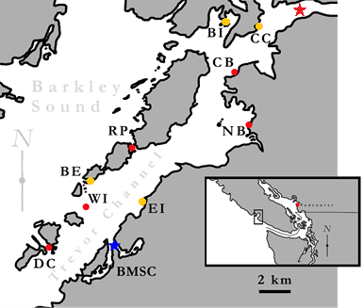

**Figure 2**: Epifaunal diversity from samples of eelgrass meadow (n = 9) of area 0.28m2 in nine meadows in Trevor Channel, British Columbia, in midsummer 2011. Asterisks indicate significant differences (P < 0.01) among sites, based on a one-way anova.

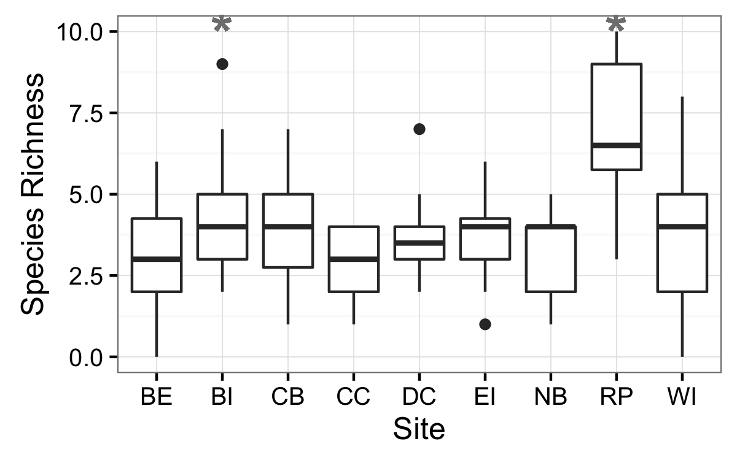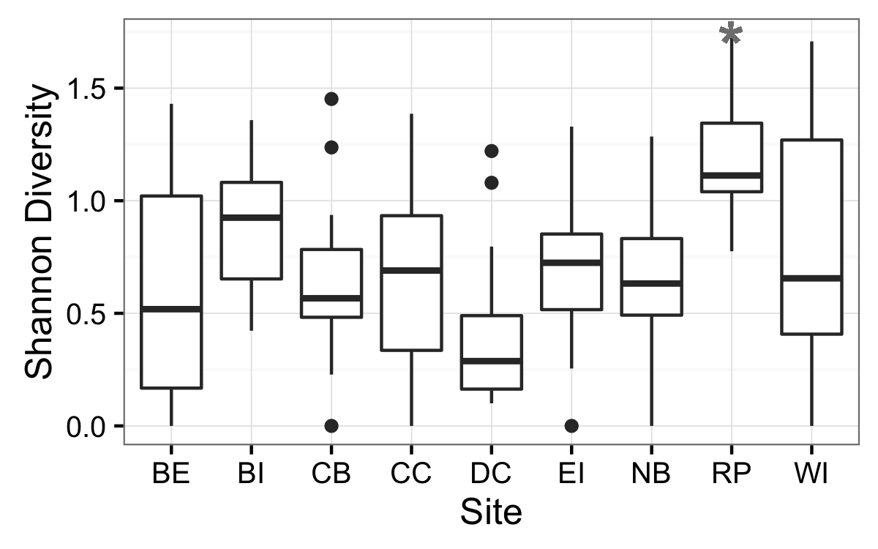

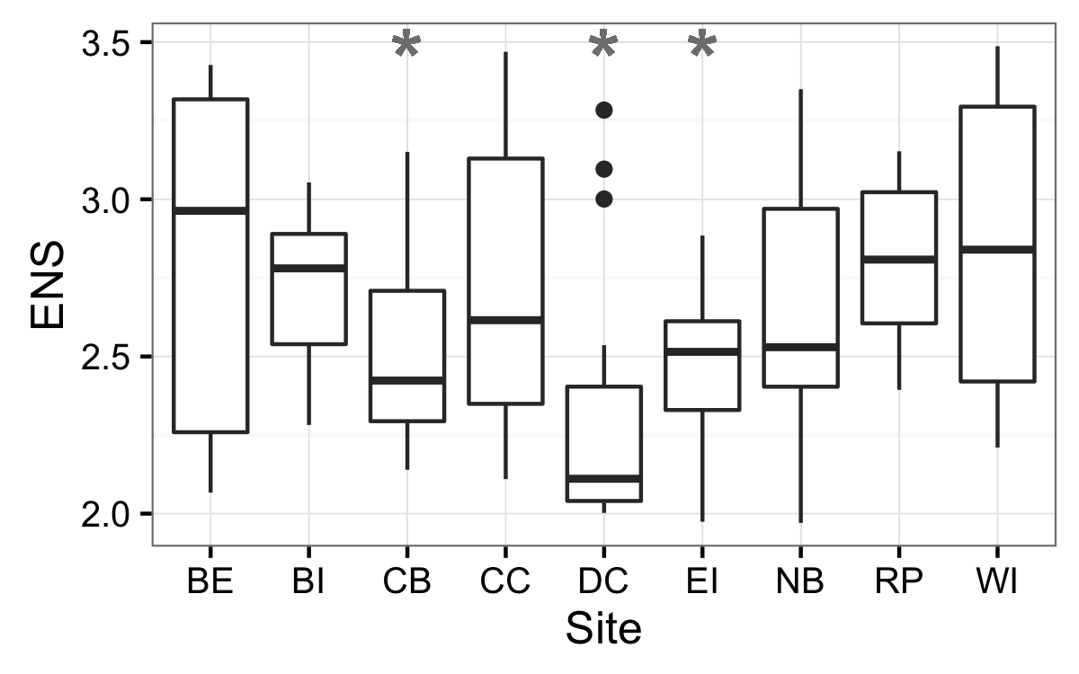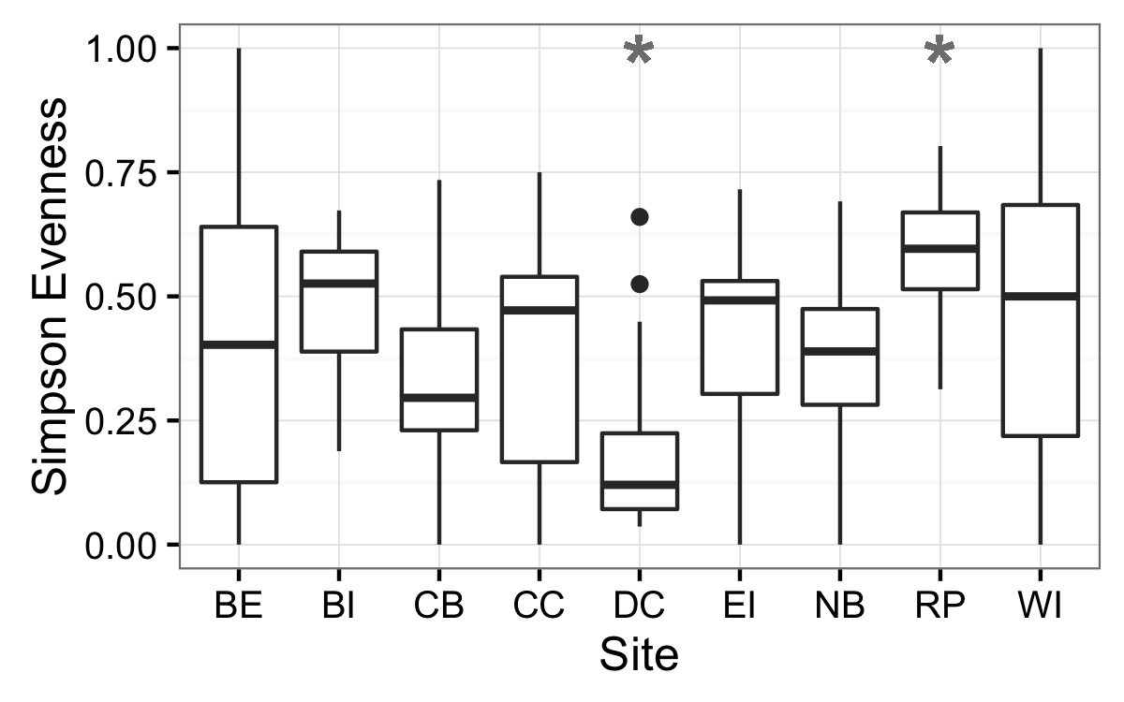

**Figure 3:** Dispersion of multivariate community for each site and sample period using the Bray-Curtis dissimilarity index (Appendix 4). Red filled points represent average median value observed in null model analyses.

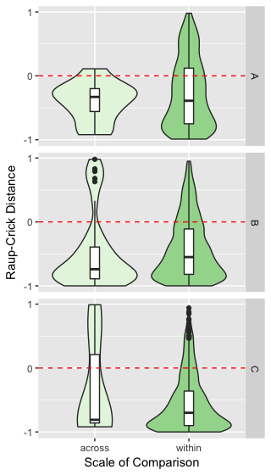

**Figure 4:** Nonmetric Multidimensional Scaling (NMDS) plot visualizing community composition across all sites and times. Polygons represent multivariate communities for each meadow at one time (n = 16 samples per meadow). Polygon area is representative of observed within-meadow beta diversity, such that a larger polygon indicates greater beta diversity among the plots sampled from that meadow. Overlap of polygons indicates similar species composition and relative abundance from plots sampled within different meadows. First two letters of polygon labels are the site codes, given in Table 1 and Figure 1, and the third letter indicates the time period sampled (A = May, C = July, and E = August).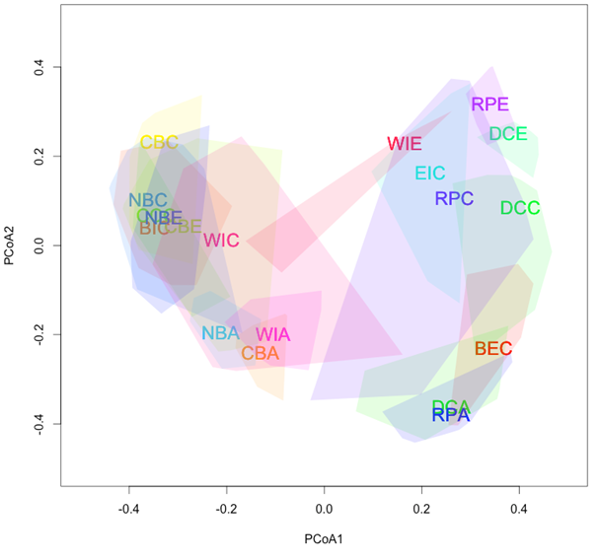

Appendix table S1

**Table A1:** Model selection results for plot-level (n = 9) univariate richness indices across nine eelgrass meadows in July 2011.

|  |  |  |  |  |  |  |
| --- | --- | --- | --- | --- | --- | --- |
| **Model** |  | **Df** | **logLik** | **AICc** | **Delta** | **wt** |
| **alpha** |  |  |  |  |  |  |
| G | Y ~ site | 10 | -271.06 | 565.8 | 0.00 | 1 |
| . | Y ~ area | 3 | -301.43 | 609.0 | 43.27 | 0 |
| D | Y ~ 1 | 2 | -302.59 | 609.3 | 43.50 | 0 |
| A | Y ~ fetch | 3 | -302.28 | 610.7 | 44.97 | 0 |
| B | Y ~ dfw | 3 | -302.51 | 611.2 | 45.43 | 0 |
| C | Y ~ dfw*fetch | 5 | -302.08 | 614.6 | 48.82 | 0 |
| F | Y ~ area*fetch | 5 | -302.14 | 614.7 | 48.95 | 0 |
|  |  |  |  |  |  |  |
| **H’** |  |  |  |  |  |  |
| G | Y ~ site | 10 | -66.12 | 153.9 | 0.00 | 0.998 |
| B | Y ~ dfw | 3 | -81.39 | 168.9 | 15.07 | 0.001 |
| F | Y ~ area*fetch | 5 | -79.57 | 169.6 | 15.69 | 0 |
| C | Y ~ dfw*fetch | 5 | -80.07 | 170.6 | 16.70 | 0 |
| D | Y ~ 1 | 2 | -83.42 | 170.9 | 17.05 | 0 |
| A | Y ~ fetch | 3 | -83.05 | 172.3 | 18.39 | 0 |
| . | Y ~ area | 3 | -83.05 | 172.3 | 18.40 | 0 |
|  |  |  |  |  |  |  |
| **S** |  |  |  |  |  |  |
| G | Y ~ site | 10 | 18.37 | -15.1 | 0.00 | 0.797 |
| F | Y ~ area*fetch | 5 | 11.18 | -11.9 | 3.18 | 0.163 |
| C | Y ~ dfw*fetch | 5 | 9.04 | -7.6 | 7.46 | 0.019 |
| . | Y ~ area | 3 | 6.05 | -5.9 | 9.18 | 0.008 |
| A | Y ~ fetch | 3 | 5.63 | -5.1 | 10.02 | 0.005 |
| B | Y ~ dfw | 3 | 5.48 | -4.8 | 10.32 | 0.005 |
| D | Y ~ 1 | 2 | 3.88 | -3.7 | 11.43 | 0.003 |
|  |  |  |  |  |  |  |
| **ENS** |  |  |  |  |  |  |
| G | Y ~ site | 10 | -52.19 | 126.2 | 0.00 | 0.493 |
| F | Y ~ area*fetch | 5 | -58.67 | 127.8 | 1.57 | 0.225 |
| C | Y ~ dfw*fetch | 5 | -59.21 | 128.9 | 2.66 | 0.130 |
| . | Y ~ area | 3 | -61.59 | 129.4 | 3.13 | 0.103 |
| B | Y ~ dfw | 3 | -63.13 | 132.4 | 6.20 | 0.022 |
| A | Y ~ fetch | 3 | -63.13 | 133.1 | 6.80 | 0.016 |
| D | Y ~ 1 | 2 | -64.88 | 133.9 | 7.62 | 0.011 |

